**Loading Data:**

Under preprocess tab 🡪 open fille 🡪 select supermarket.iris 🡪 click “Open”

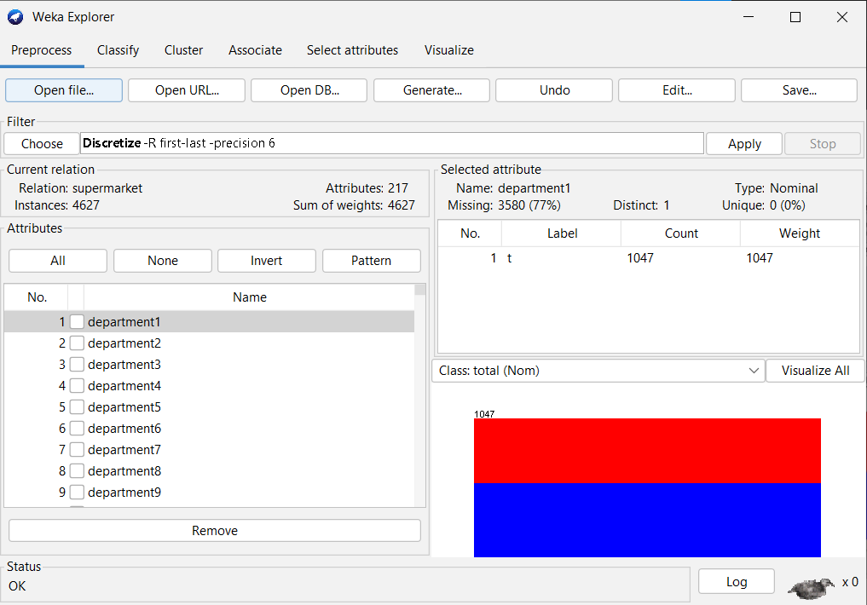

**Associators:**

Click Associate tab 🡪 click choose 🡪 choose Apriori option

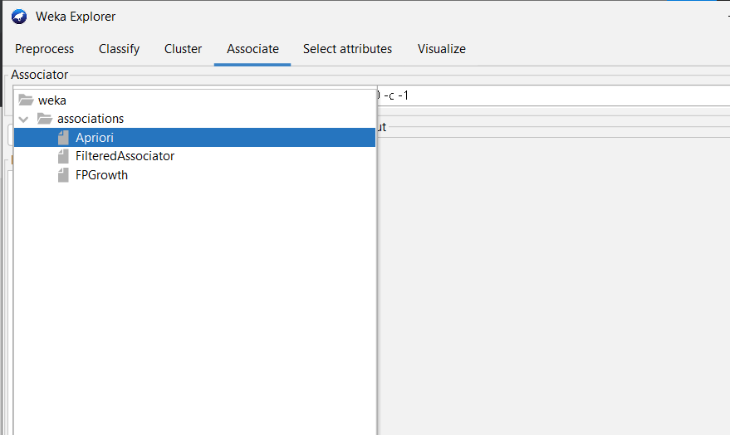

To set the parameters for the Apriori algorithm, click on its name, a window will pop up -

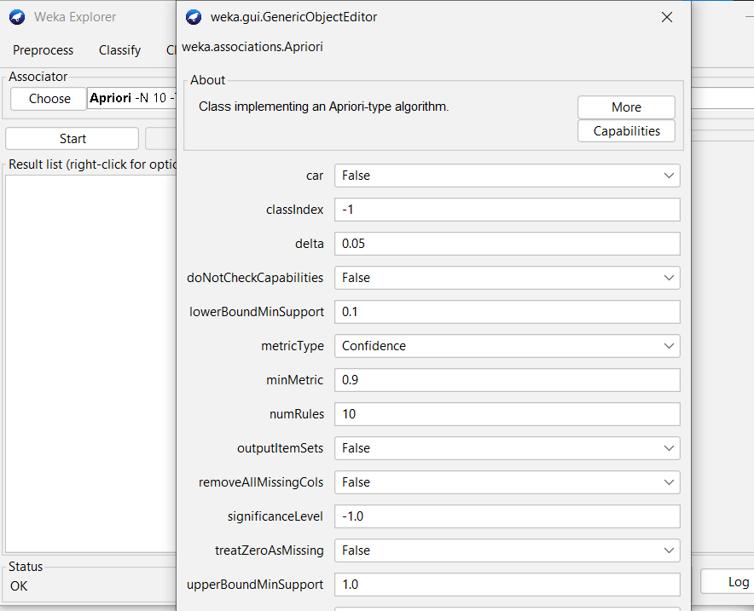

click the **Start** button. After a while you will see the results as shown in the screenshot below −

